Objective: See if modern modeling methods can outperform original MERON model at malnutrition classification using the same pictures as MERON had access to.
Candidate modeling methods:
- Neural Network Model: Similar to original MERON model. Standard neural network approach using resnet-50 extracted features.
- Landmark Model: Uses facial landmark features for prediction. Test a few different algorithms with these features:
  - Random Forest
  - Gradient Boosting
  - Logistic Regression
- ResNet50 Model: Use resnet50 neural net architecture directly. Do transfer learning with pre-trained ResNet50, and fine tune additional layers.
- Multimodal Fusion Model: Same as 1), but use both ResNet50 and facial landmark features.
- XGBoost Model: XGboost model with resnet50 extracted features.
- Vision Transformers. Used ViT hugging face model. Had technical issues and results not obtained

Results
Metrics Comparison
Metric | Original MERON | Neural Network | Landmark | ResNet50 | Multimodal Fusion | XGBoost
F1-score | .29 | .18 | .31 | .21 | .25 | .18
Precision | .23 | .20 | .18 | .33 | .30 | .20
Recall | .40 | .16 | .99 | .69 | .22 | .16
Accuracy | .68 | .73 | .18 | .72 | .77 | .73

Original MERON Model Charts
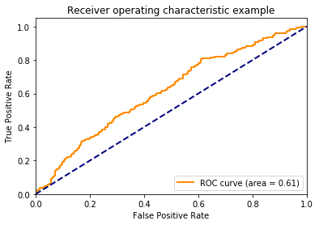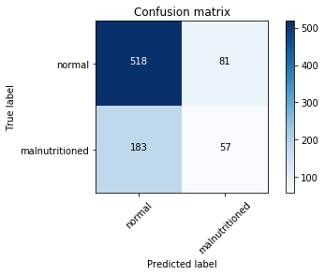
Sample modern model charts (Multi-modal fusion)
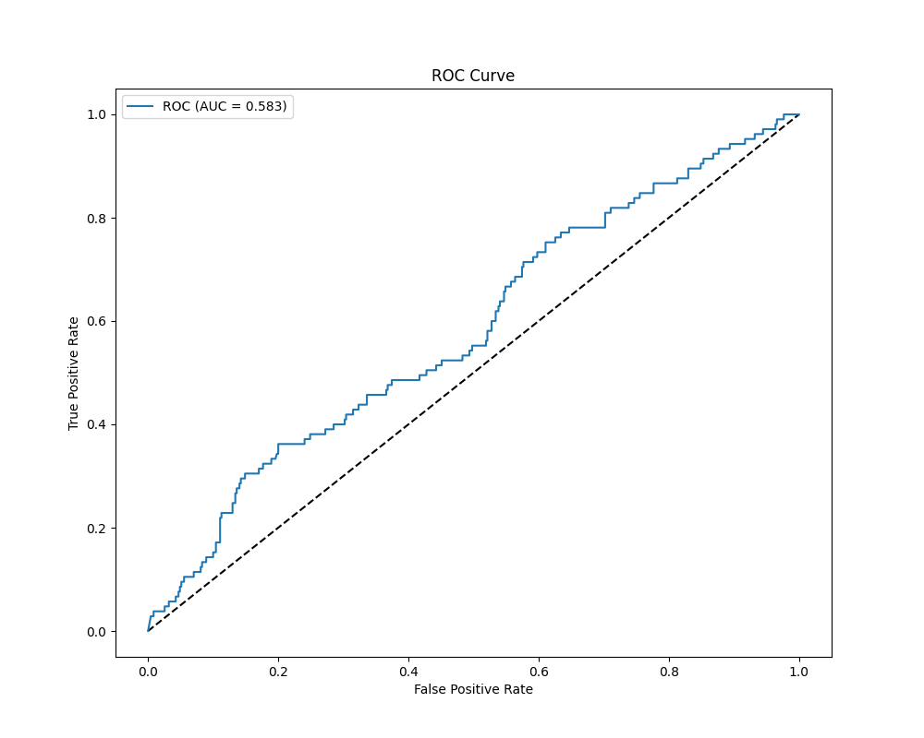

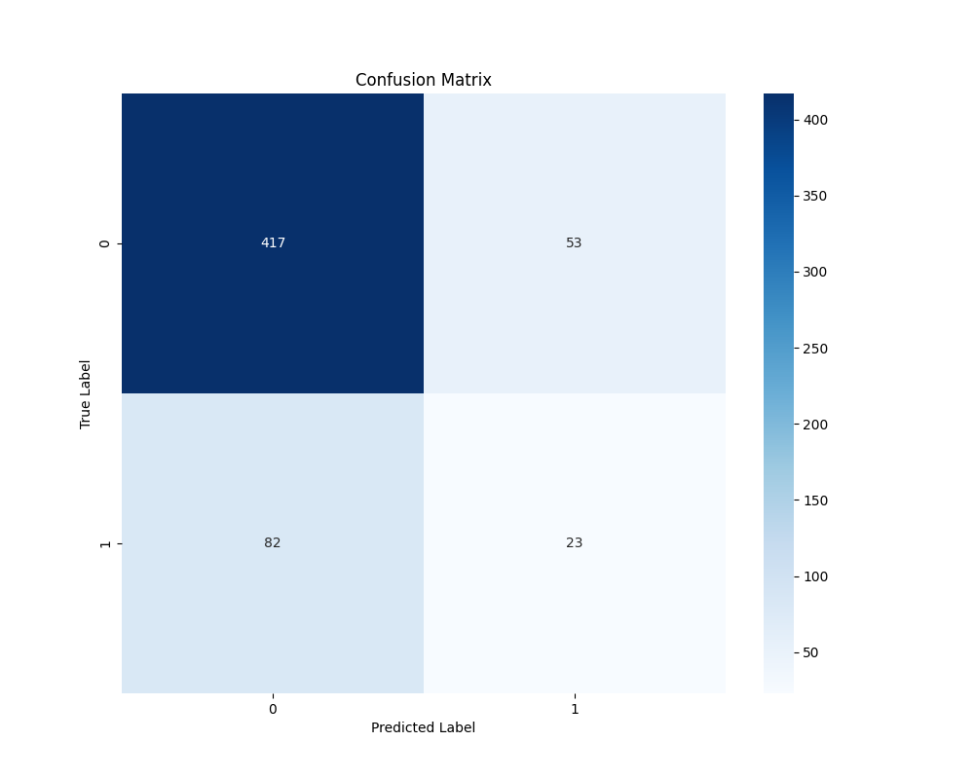
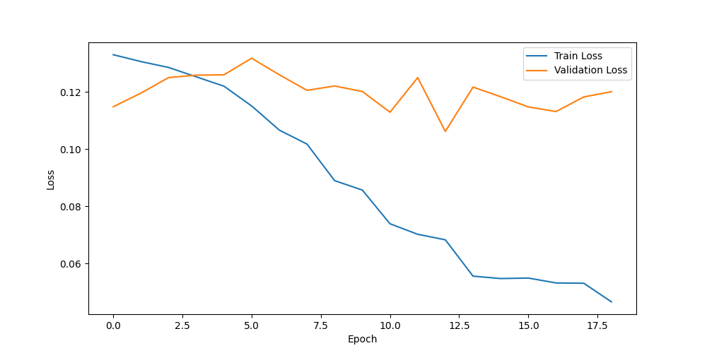

Conclusion
Modern models do not appreciably do better than original MERON model. No models achieved higher f1-score than original model. Showed signs of overfitting during several training (see training curve), it’s a sign we likely need more data and/or stronger signals in the data to build reasonable prediction models.

For modeling code, see meron2 folder of https://github.com/Luke-Patterson/MERON_model

